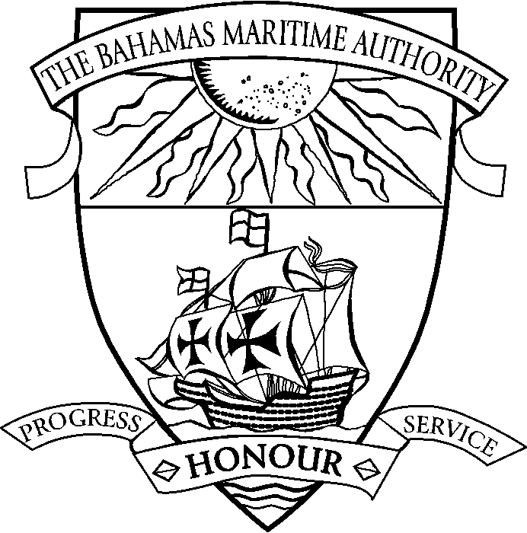 | THE COMMONWEALTH OF THE BAHAMAS  REQUIREMENTS FOR PROVISIONAL AND  PERMANENT REGISTRATION  OF NEW SHIPS  (Delivered directly from the shipyard and no previous flag)
Listed below are the documents which are required to be forwarded to the Authority to complete the registration of a vessel. Applicants are requested to complete those pages of the application form that are relevant to the vessel being registered. Please note it is also necessary to submit the payment of all applicable fees including the first year’s annual fee (prorated) in order for the provisional registration of the vessel to be given effect.
 |  |  | Provided | Date
 | Application Form Contents
 | Application to Register a Ship | R102
 | Authorised Officer Declaration (Must be notarised) | R103
 | Registration of Managing Owner | R104
 | Declaration of Ownership (May be notarised or signed in presence of Registrar) | R105
 | Application for Safe Manning Document | R106
 | Application for Permit to Operate a High Speed Craft | R107
 | URCA Ship Radiocommunications Licence Application | R108
 | Application for MLC 2006 DMLC Part 1 | R109
 | Application for Continuous Synopsis Record (CSR) | Appendix 1
* | Application for LRIT Conformance Test Report
 | Certificates Required
 | Bill of Sale and/or Builder’s Certificate (Must be notarised)
 | Copy of Protocol of Delivery and Acceptance
 | Copy of Certificate of Company Incorporation
 | Original Certificate of Good Standing (Must be less than 3 months old)
 | Civil Liability for Bunker Oil Pollution Damage (Bunker CLC) (All vessels over 1000 GT)
 | Civil Liability for Oil Pollution Damage (CLC) (Tankers only)
 | Civil Liability for the Removal of Wrecks (Wreck CLC)
 | Certificate of Survey
 | International Tonnage Certificate
 | Certificate of Insurance of Seafarer Repatriation Costs and Liabilities under Regulation 2.5.2
 | Certificate of Insurance of Shipowners Liability under Regulation 4.2
 | Certificate of Entry
 | Bahamas ISM Code Document of Compliance
 | Exemptions/Equivalent Arrangements certificates
 | OTHER
 | Notification of Radio Accounting Authority (AAIC)
 | Ancillary Fees
 | Annual Fee
* | Ship’s Carving and Marking Note
* | Initial Inspection Report (Provided by Approved BMA Inspector)
* - Required for Permanent Registration

