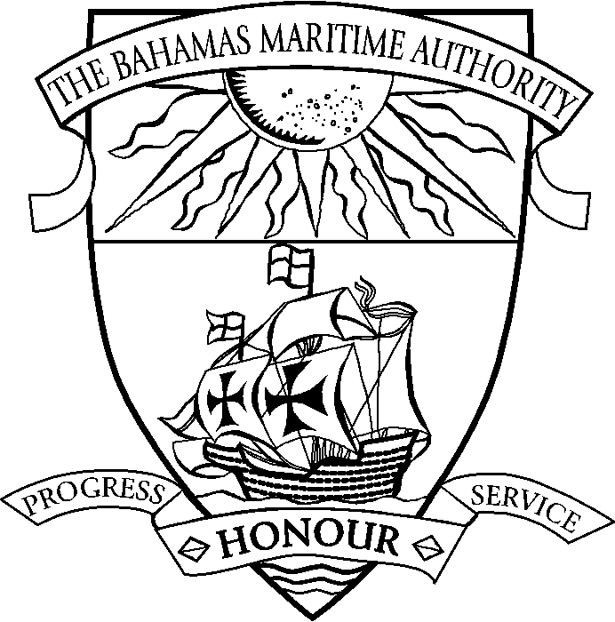 | THE COMMONWEALTH OF THE BAHAMAS  REQUIREMENTS FOR PROVISIONAL REGISTRATION  OF SHIPS BEING BUILT
Listed below are the documents which are required to be forwarded to the Authority to complete the registration of a vessel being built. Applicants are requested to complete those pages of the application form that are relevant to the vessel being registered. Please note it is also necessary to submit the payment of all applicable fees including the first year’s annual fee (prorated) in order for the provisional registration of the vessel to be given effect.
 |  |  | Provided | Date
 | Application Form Contents
 | Application to Register a Ship | R102
 | Appointment of Authorised Officer (Must be notarised) | R103
 | Registration of Managing Owners | R104
 | Declaration of Ownership (May be notarised or signed in presence of Registrar) | R105
 | Certificates Required
 | Bill of Sale/Document of Title and/or Builder’s Certificate (Must be notarised)
 | Copy of Protocol of Delivery and Acceptance
 | Copy of Certificate of Company Incorporation
 | Original Certificate of Good Standing (Must be less than 3 months old)
 | Civil Liability for Bunker Oil Pollution Damage (Bunker CLC) (All vessels over 1000 GT) – As applicable
 | Civil Liability for the Removal of Wrecks (Wreck CLC) (All vessels over 300 GT) – As applicable
 | Civil Liability for Oil Pollution Certificate (CLC) (Tankers only)
 | Certificate of Survey (If available)
 | International Tonnage Certificate (If available)
 | Bahamas ISM Code Document of Compliance
 | OTHER
 | Ancillary Fees
 | Annual Fee
 | Note: A list of the remaining application forms and certificates which must be submitted prior to the vessel’s completion will be forwarded.

