Yacht Stability Information Booklet
Version 1.0
bahamasmaritime.com

CONTENTS
1 FOREWORD 4
2 GENERAL PARTICULARS 5
3 PRINCIPAL DIMENSIONS 6
4 NOTES TO THE MASTER 7
4.1. General Instructions 7
4.2. General Stability Requirements 7
4.3. Precautions against capsize 7
4.4. Angles of downflooding 8
4.4.1. Maximum Steady Heel Angle to Prevent Downflooding in Gusts. 10
4.4.2. Curves of maximum Steady Heel Angle to Prevent Downflooding in Squalls 11
4.4.3. Examples Showing the Use of the Maximum Steady Heel Angle Curves 12
4.5. Operating Restrictions 13
4.6. Master’s Shipboard Procedures 13
5 SAIL PLAN 15
6 DRAUGHT MARKS, FREEBOARD MARK AND DATUM REFERENCE INFORMATION 16
7 TANK CAPACITIES, ARRANGEMENT OF TANKS AND FEREE SURFACE MOMENTS 17
8 LOADING CONDITIONS 18
9 SAMPLE STABILITY LOADING CONDITION 19
9.1 Condition No. [YY Departure 100%] Consumables 19
10 EXPLANATION AND NOTES ON COMPLETING SAMPLE STABILITY CONDITION 20
10.1 Calculating the displacement and centres of gravity 20
10.2. Obtaining Draught and trim 20
10.3. Stability compliance 20
11 HYDROSTATIC PARTICULARS 21
12 CROSS CURVES OF STABILITY 22
13 NOTES ON USE OF KN CURVES 23
14 TANK USAGE AND FREE SURFACE MOMENTS 24
15 MAX KG LIMITING CRITERIA (KG_{MAX}) 25
15.1 Notes on use of the curve 25
16 BEAUFORT SCALE OF WIND SPEEDS AND CORRESPONDING PRESSURES 26
17 LIGHTSHIP HISTORY 27
18 INCLINING EXPERIMENT REPORT 28
APPENDIX 1 – NOTES TO CONSULTANTS 29
REVISION HISTORY 32

1 FOREWORD

This Yacht Stability Information Booklet is provided by the Bahamas Maritime Authority (“BMA”) and is intended to provide yacht stability information that is required to be on board under the provisions of the Bahamas Large Charter Yacht Code (BLYC) and Bahamas Small Charter Yacht Code (BSYC).

Reference to the “Code” means either the BLYC or BSYC. The consultant and yacht owner/manager shall specify the relevant code BLYC or BSYC.

The consultant and yacht owner/manager shall fill the relevant sections with information as per the type of yacht.

2 GENERAL PARTICULARS

Yacht Name
Official Number
Port of Registry
Owner Name and Address
Yacht Survey Organisation
Builder
Yard Number
Keel Laying Date

3 PRINCIPAL DIMENSIONS

Length overall (LOA) (metres)
Length between perpendiculars (LBP) (metres)
Maximum beam (metres)
Depth (metres)
Assigned freeboard (metres)
Maximum summer loaded draught (metres)
Maximum displacement at summer load draught (tonnes)
Gross tonnage
Area of operation
[insert actual text for Short Range yachts, actual imposed limitation, or Area Category, otherwise, if appropriate, state “Unlimited”]
Standard of survivability
[State “Intact stability” or “Intact & damage stability”, as appropriate]
Number of crew
Number of passengers

4 NOTES TO THE MASTER

4.1. General Instructions
The loading conditions shown in this booklet represent typical service conditions. Where a loading condition departs from those shown in this book a separate calculation should be made to ensure compliance with the stability criteria.

4.2. General Stability Requirements
It is important to ensure that in any sailing condition the stability of the yacht complies with the relevant criteria of section 11 of the Code.

[This yacht meets the Code requirement for a sailing mono hull as follows:
a. GZ positive range of _____ degrees
b. Angle of steady heel _____ degrees]

[This yacht is capable of sailing under power provided by the main engines and has to comply with stability requirements for both motor yachts and sailing yachts.]

[Limiting KG curves for this yacht are provided at page [_____]. These curves include the provisions of [intact/intact and damage] stability criteria for motor yachts contained in the Code.]

[If the vertical centre of gravity of any sailing condition, after correction for free surface effects, lies below the limiting KG curve on page [_____] compliance with the requirements of the Code for [intact/intact and damage] stability is ensured. It must be appreciated however, that compliance can never guarantee survivability in the event of damage and good seamanship must prevail under such circumstances.]

[This vessel has not been assessed for damage stability, and therefore might not remain afloat in the event of damage or flooding.]

[This yacht has been provided with _____ tonnes of fixed ballast for stability purposes. The position of this ballast is shown on the drawing at page _____. This ballast is not to be moved or removed without prior consultation regarding the consequences on stability. Should the ballast be required to be removed for survey/repair or any other reason it must be returned to its original position and made secure against movement.]

[Where yachts are fitted with keels that may be retracted, information is to be provided on the use and effects on stability, with reference to the appropriate loading conditions included in the book]

4.3. Precautions against capsize
Compliance with the stability criteria does not ensure immunity against capsize or absolve the Master from his responsibilities. Masters should therefore exercise prudence and good seamanship having regard to the season of year, experience of the crew, weather forecast and the navigational zone, and should take appropriate action as to the speed, course and sail setting warranted by the prevailing conditions.

Before a voyage commences care should be taken to ensure large items of equipment and stores are properly stowed to minimise the possibility of both longitudinal and transverse shifting under the effect of acceleration caused by pitching and rolling, or in the event of a knockdown to 90 degrees.

All external hull doors and flush hatches [to be listed] are to be closed and secured.

The number of slack tanks should be kept to a minimum. Where port and starboard tanks are cross coupled, such connection should be closed at sea to minimise the reduction in stability.

In adverse weather conditions and where there is the possibility of encountering a severe gust, squall or large breaking wave, all exposed doors, hatches, skylights, vents, etc. should be closed and securely fastened to prevent the ingress of water. Storm boards and shutters etc. should be fitted.

The amount of sail carried is at the discretion of the Master and his decision will have to take into account many factors.

4.4. Angles of downflooding
The angle of downflooding is the angle of heel at which progressive downflooding of the yacht will occur due to the immersion of an opening. For this yacht the following openings have been identified:

Description | Area of opening (m²) | Angles of immersion (degrees)
Saloon [X] | [A] | [01] | [04]
Crew [Y] | [B] | [02] | [05]
Galley [Z] | [C] | [03] | [06]

Critical Flooding is deemed to occur when the lower edge of openings have an aggregate area in m², greater than:
$$\frac{Vessel displacement (tonnes)}{1500}$$

The master should note that the presence of vents and skylights significantly reduce the ability of the yacht to withstand downflooding and with such openings securely closed the safety of the yacht is enhanced considerably.

In assessing the risks of downflooding, the Master should be guided by figures 1 and 2:
Figure 1: shows the maximum recommended steady heel angle to prevent downflooding in gusts. Operation of the yacht at a greater heel angle would result in downflooding if it were to encounter the strongest possible gust in the prevailing turbulent air stream, which could exert a heeling moment equal to twice that of the mean wind.

Figure 2: shows the maximum recommended steady heel angle to prevent downflooding in squalls. Operation of the yacht at a greater heel angle would result in down flooding if it were to encounter the heeling effects of a squall arising from a storm or frontal system which may result in a heeling moment many times greater than that of the mean wind. For this reason, the Master should have regard to the maximum steady heel angle curves presented for a range of squall speeds.

By using the readings from the inclinometer and anemometer the master should be able to determine the degree of risk of capsize in gusts or squalls which may occur in the prevailing weather system. He may then decide to shorten sail together with other actions he considers necessary.

Additional care should be taken when sailing with the wind from astern, as in the event of the vessel broaching or a gust striking the yacht on the beam, the heeling effects of the wind may be increased to a dangerous level when the preceding heel angle was small.

4.4.1. Maximum Steady Heel Angle to Prevent Downflooding in Gusts.

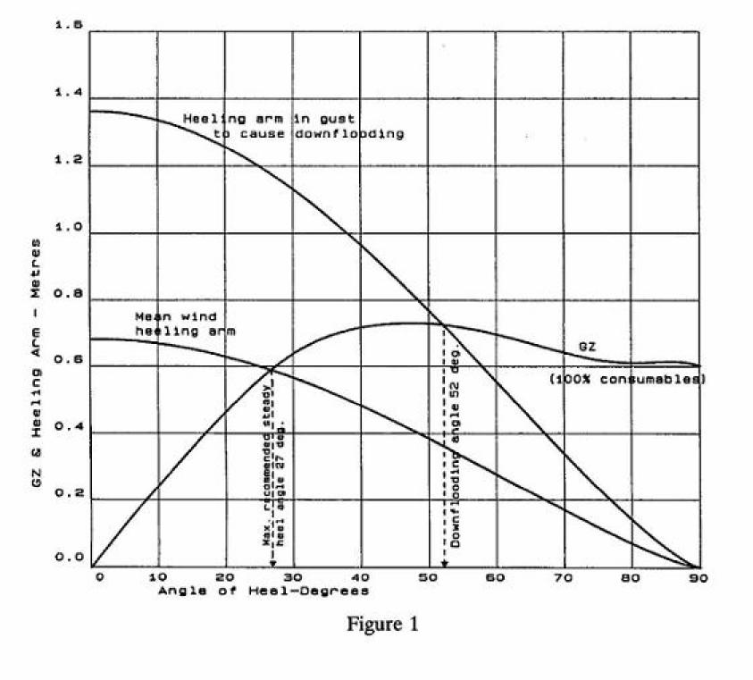[Figure 1 is to be replaced by a curve specific to the yacht in question]

GUSTING CONDITIONS
When sailing in a steady wind the yacht heels to the angle at which the heeling arm curve intersects the GZ curve. When struck by a gust the heel angle will increase to the intersection of the gust heeling arm curve with the GZ curve. The heeling moment increases in proportion to the square of the apparent wind speed.

The derived angle of steady heel for this yacht is _____ degrees. Provided the yacht is sailed at a steady angle of heel less than this value it should be capable of withstanding a wind gust equal to 1.4 times the actual wind velocity (i.e. twice the actual wind pressure) without immersing critical downflooding openings. The critical downflooding openings for this yacht are as shown in table _____ on page _____. This heel angle is shown on the curves of maximum Steady Heel Angle to prevent downflooding in Squalls at page _____.

4.4.2. Curves of maximum Steady Heel Angle to Prevent Downflooding in Squalls

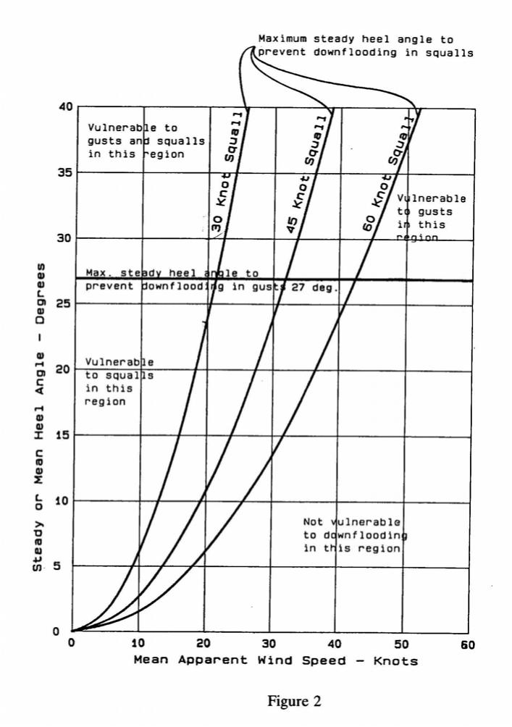
[Figure 2 is to be replaced by a curve specific to the yacht in question]

SQUALL CONDITIONS
Curves of the maximum steady heel angle indicate the range of mean or steady heel angles beyond which the yacht will suffer downflooding in the event of a squall.

Operation of the yacht in cyclonic conditions particularly in the hours of darkness, where severe squalls are imminent requires the recommended maximum steady heel angle to be reduced depending on the mean apparent wind speed in accordance with the curves presented above.

4.4.3. Examples Showing the Use of the Maximum Steady Heel Angle Curves

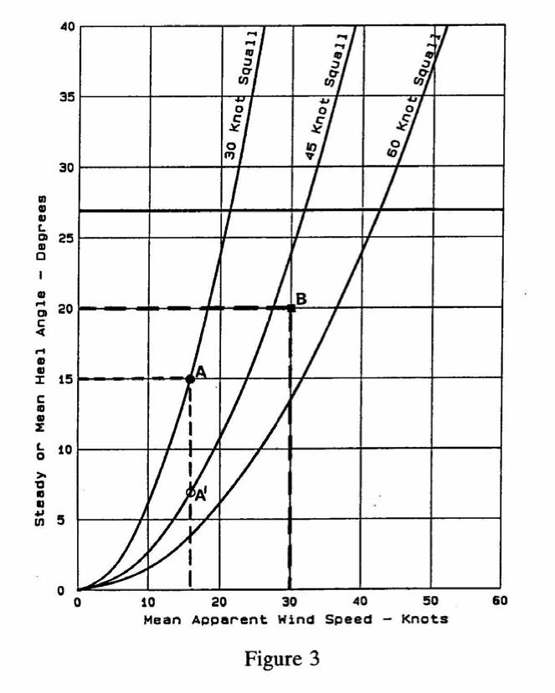
Example A
The yacht is reaching, with a steady apparent wind speed of 16 Knots. The mean heel angle is 15 degrees. Forecasts and visible cumulonimbus clouds suggest squalls may be imminent. By plotting the heel angle and wind speed (point A in figure 3) the indication is that the yacht will be in danger of heeling to the downflooding angle in squalls of 30 knots. In order to increase safety from downflooding, say, to withstand squalls of up to 45 knots, sails should be handed or reefed to reduce the mean heel angle to 7 degrees (point AI in Figure 3) or less.

Example B
The yacht is beating in gusty conditions with a mean apparent wind speed of 30 knots. The mean heel angle is 20 degrees. No squalls are expected. The heel angle is significantly less than 27 degrees, the maximum recommended steady heel angle, and there is therefore a good safety margin against downflooding in a strong gust. Plotting these values of wind speed and heel angle (point B in Figure 3) also indicates that the yacht would not be vulnerable to downflooding in a squall unless it resulted in a wind speed in excess of about 50 knots. There is thus no need to reduce sail area on the grounds of stability.

4.5. Operating Restrictions
[If there are any operating restrictions, details are to be included in this section. Such operating restrictions could include, but are not necessarily limited to, items such as restricted range/weather, maximum speed and handling of the yacht, limitations on use of consumable fluids, trim restrictions etc. If there are no operating restrictions a note is to be included to that effect.]

4.6. Master’s Shipboard Procedures
[Consideration of damage stability has been assumed with the yacht initially in the upright condition. Therefore, in the event of damage an attempt should be made to either reduce the heeled angle or heel slightly away from the damage.]

[This section is to include any procedures relating to the safe operation of the yacht affecting stability or survivability following damage, hit by squalls etc. that the master is to be made aware of in order that the appropriate action can be taken either in the course of normal seagoing preparation or in the case of an emergency.

Information and instructions to the master on vessel safety when using a deck crane or other lifting device should be included as per BSYC Sec.11.10.4

The following are non-exhaustive examples of what is expected. These are to be modified as required to suite the specific yacht in question, and when applicable lifting operation instruction shall be included:

“As part of familiarisation with the yacht all persons, including passengers, should be briefed on the operation of sliding watertight doors and advised to keep well clear when they are closing.”

“IN SHELTERED ANCHORAGES AND IN PORT:
The master is responsible for evaluating the risks and hazards present and taking appropriate precautions.
It is recommended that the door from the garage to the engine room is kept closed whenever the transom door is open.”

“PREPARING FOR SEA.
External hull doors and flush hatches (to be itemised) to be closed, secured and recorded.
Internal hinged WT doors (to be itemised) are to be closed and secured.
Internal sliding WT doors (to be itemised) are to be tested immediately before departure.
Sidelights capable of being opened are to be secured closed.”

“PREPARING FOR ROUGH WEATHER PASSAGE.
The master is responsible for taking appropriate precautions whenever rough weather is anticipated. The precautions should include (but are not limited to) the following:
      - All loose gear (including tenders etc.,) on deck, and in the garage/lazarette are to be securely lashed in place.
      - Large or Heavy Items of furniture to be secured.
      - The shutters provided are to be put up over the windows.
      - Deadlights are to be closed and secured.
      - Secure closing devices as appropriate.”

“AT SEA
Internal sliding WT doors, situated at _____ may be left open, but consideration should be given to closing them when risk of hull damage and flooding increases e.g. in fog, in shallow rocky waters, in congested shipping lanes, when entering and leaving port and at any other time the master considers appropriate. Sliding WT doors should be checked daily to ensure that nothing has been placed in way of the door or where it might fall into the opening and prevent the door from closing.

Sliding WT doors should be checked daily to ensure that nothing has been placed in way of the door or where it might fall into the opening and prevent the door from closing.”

Internal hinged watertight doors, situated at _____, should remain closed but may be opened when passing through.

5 SAIL PLAN

[A copy of the sail plan and details is to be included here]

6 DRAUGHT MARKS, FREEBOARD MARK AND DATUM REFERENCE INFORMATION

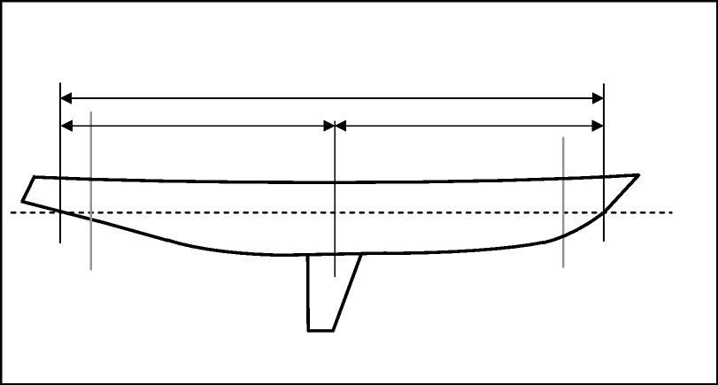
Fwd draught mark
Aft draught mark
Y (m)
X (m)
LBP (m)
FP
AP

Top of deck at side
Assigned
summer
freeboard

Summer
draught

Underside of keel

Longitudinal datum | = | [AP/amidships/FP]
Transverse datum | = | centreline
Vertical datum | = | [base line/underside of keel (amidships/AP)]
Aft perpendicular | = | [________metres aft of amidships]
Fwd perpendicular | = | [________metres forward of amidships]
Aft draught marks [N] metres AB | = | [________ metres aft of amidships (X)]
Fwd draught marks [N] metres AB | = | [________ metres forward of amidships (Y)]

[the above drawing is for reference only, the appropriate profile is to be included to show the keel thickness or the rake of keel and include dimensions]

7 TANK CAPACITIES, ARRANGEMENT OF TANKS AND FEREE SURFACE MOMENTS

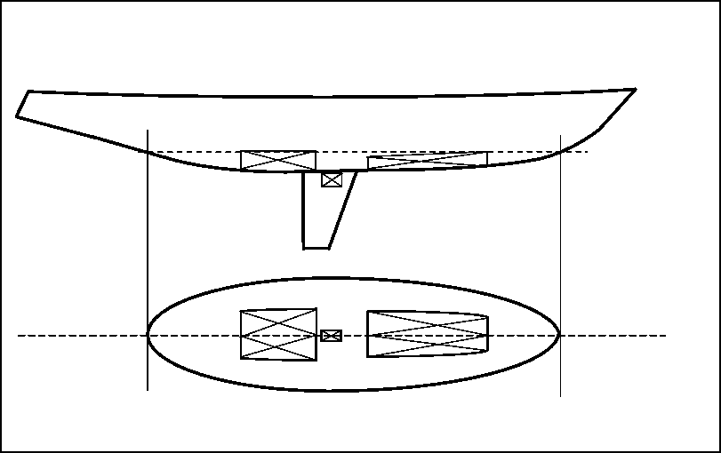

[the above drawing is for reference only, the appropriate profile is to be included to show the correct profile and tank arrangement]

No. | Name | SG | Frames | Volume | Mass | VCG | LCG | TCG | FSM

8 LOADING CONDITIONS

The following conditions of loading are to be provided:

- Departure (100% consumables)
- Half Load (50% consumables) (OPTIONAL CONDITION)
- Arrival (10% consumables)
- Practical Departure and arrival conditions if different from above
- Conditions involving lifting appliances (when appropriate).

[Stability information is to be submitted for consideration to show 100% and 10% consumables. After consideration, providing the difference between the two loading conditions is agreed to be small only one condition (the most onerous) need be included in the stability information to be endorsed and provided for the use of the master or person in charge of the yacht.]

If the difference in draught and trim between departure and arrival conditions is small, the angle of downflooding to the worst point will, to all intents and purposes be the same and only one loading condition need be included. Also, providing there is little change in the vertical centre of gravity the GZ curve will be the same. It is to be noted that the most onerous loading condition should include the most onerous disposition of sails and spars resulting in the highest vertical centre of gravity (KG). Noting this, the maximum steady heel angle will be the same and as long it is greater than 15 degrees the requirements of the Code will be met.]

Inclusion of a lightship condition in the stability information is not considered to be of any onboard practical use and may be excluded.

[Whereas the following may indicate that certain items may be excluded from the stability information provided to the master, full details are still to be submitted to the BMA/Yacht Survey Organisation to show that the yacht complies.]

[Where yachts are fitted with keels that may be retracted, both conditions are to be fully considered in the stability information to be submitted.]

9 SAMPLE STABILITY LOADING CONDITION

9.1 Condition No. [YY Departure 100%] Consumables
ITEM | Load % | WT | LCG m forward | Long Mom | VCG above base | Vertical Mom | FSM
Passengers and effects | - |  |  |  |  |  | -
Crew and effects | - |  |  |  |  |  | -
Provisions and stores Deck A | - |  |  |  |  |  | -
Provisions and stores Deck B | - |  |  |  |  |  | -
Provisions and stores Deck C | - |  |  |  |  |  | -
Permanent ballast | - |  |  |  |  |  | -
Jetskis etc. | - |  |  |  |  |  | -
Tender | - |  |  |  |  |  | -
Fresh water tank (P)
Fresh water tank (S)
Diesel oil tank (P)
Diesel oil tank (S)
Ballast water tank (P)
Ballast water tank (S)
Lub. oil tank
Grey water tank
Total deadweight |  |  |  |  |  |  | -
Lightship weight |  |  |  |  |  |  | -
Displacement

VCG above base |  | $Trim= \frac{\left(Separation of LCB \& LCG\right)×Displacement}{MCT ×100}=$ m  $Draught Aft \left(D_{A}\right)=D_{M}±\frac{LCF}{LCB} ×Trim=$ m  $Draught Fwd D_{F}=D_{M}±Trim=$ m
Free surface correction (FSC)
KG liquid (KG_{L})
KG_{Max}

Mean Draught at LCF (D_{m})
LCF (m forward AP)
LCB (m forward AP)
MCT (TM/cm)
KM_{T} (m AB)

10 EXPLANATION AND NOTES ON COMPLETING SAMPLE STABILITY CONDITION

10.1 Calculating the displacement and centres of gravity
- Add the appropriate weights in column 3 (WT) and, for fluids, also complete column 2 (Load %) to indicate the % fill for each tank.
- Add the longitudinal and vertical centres of gravity in columns 4 (LCG) and 6(VCG) respectively.
- Multiply the weight of each item by its centre of gravity to obtain the longitudinal and vertical moments and enter in columns 5 (Long Mom) and 7 (Vertical Mom) respectively.
- From the tank capacity table [page NN] enter Free Surface Moment (FSM) into column 8.
- Sum columns 3, 5 and 7 and enter totals in the Total Dead Weight row.
- Sum Total Dead Weight and Light Ship Weight and enter total in Displacement row column 3.
- Similarly sum Total Dead Weight and Light Ship longitudinal and vertical moments and enter totals in the Displacement row, columns 5 and 7 respectively.
- Divide Displacement row column 5 by Total Displacement row column 3 to calculate LCG for the loading condition and enter the result in column 4 of that row.
- Divide Displacement row column 7 by Displacement row column 3 to calculate VCG for the loading condition and enter the result in column 6 of that row.
- Sum column 8 (FSM) and enter total into Displacement row column 8.

10.2. Obtaining Draught and trim
- Using the hydrostatic particulars provided on page MM, for zero trim, interpolate for the Displacement of the loading condition above and obtain values for Draught, LCB, LCF, MCT and KM_{T}.
- Trim is calculated from the stated formula: If the LCB is forward of the LCG the trim is by the stern and if the LCB is aft of the LCG the trim is by the head (bow). It is to be noted that the trim so calculated is for the length used in the formulation of the hydrostatics – usually Length between perpendiculars (LBP) and will need to be corrected for the positions of the draught marks if significantly different.
- As the yacht trims about the LCF, trim is proportioned over the length (LBP) and either added to or subtracted from the mean Draught (D_{m}) depending on whether the trim is by the stern or by the head.

10.3. Stability compliance
· The Free Surface Correction (FSC) is obtained by dividing column 8 of the Displacement row by the Displacement (column 3 of the same row).
· The KG liquid (KG_{L}) is obtained by adding the FSC to the VCG in column 6 in the Displacement row. (The effect of free surface is a virtual rise in the vertical centre of gravity)
· The KG liquid (KG_{L}) is compared with the KG_{Max} obtained from page [NN]. If the KG_{L} is less than KG_{Max} the loading condition complies with the stability criteria

11 HYDROSTATIC PARTICULARS

Tabular output showing Displacement, Draught, LCB, LCF, TPC, KMT and MCT across the range of operational draughts/displacements and trims.

12 CROSS CURVES OF STABILITY

Tabular output showing KN values across the range of operational draughts/displacements and trims.

NOTE:
Water Density =1.025 T/m3
K is to underside of keel at amidships
Draught is to underside of keel at amidships

13 NOTES ON USE OF KN CURVES

KN curves for [displacements/draughts] of [X to Y tonnes/metres] are presented for angles of heel at intervals between [0 and Z] degrees.

To obtain righting arm (GZ) curves at a given displacement, the following equation should be used:

$$GZ=KN-KG \sin{θ}$$

This enables the value of GZ to be calculated at each of the heel angles presented, and subsequently plotted as in the loading conditions presented therein.

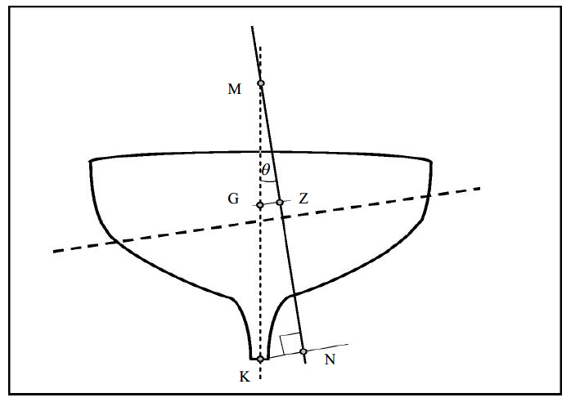

14 TANK USAGE AND FREE SURFACE MOMENTS

Provided a tank is completely filled with liquid no movement of the liquid is possible and the effect on the ship’s stability is precisely the same as if the tank contained solid material.

Immediately a quantity of liquid is withdrawn from the tank the situation changes completely and the stability of the ship is adversely affected by what is known as the ‘free surface effect’. This adverse effect on the stability is referred to as a ‘loss in GM’ or as a ‘virtual rise in VCG’ and is calculated as follows:

$$Virtual rise in VCG/ Loss of GM= \frac{Free surface moment (Tonnes m)}{Vessel displacement (Tonnes)}$$

When preparing loading conditions, it is to be noted that free surface effects must be allowed for the maximum number of tanks which are slack or shortly to become slack in that given loading condition. [This will mean that, for departure conditions all main fuel tanks as well as fresh water tanks are considered to be slack.]

The number of slack tanks should be kept to a minimum. [Where port and starboard tanks are cross coupled, such connection should be closed at sea to minimise the reduction in stability.]

Where ballast tanks are used they should be ‘pressed full’ or ‘empty’ as far as possible. Dirty water in the bilges must be kept to a minimum.

15 MAX KG LIMITING CRITERIA (KG_{MAX})

[A Table or Curve is to be included, as considered appropriate, covering the operational draught and trim range. One set of data is to be provided representing the combined effects of satisfying both intact and damage (where appropriate) stability requirements.

If possible a single table or curve (or even a single value) satisfying the whole draught and trim range based on the worst case should be provided and should be labelled to show the extent of application.

Any draught or trim limitation arising from stability consideration should be clearly documented in the Notes to the Master.]
This curve is valid only for trims between XX m by the head and YY m by the stern and between draughts of MM and NN metres and includes consideration of both intact and damage stability.

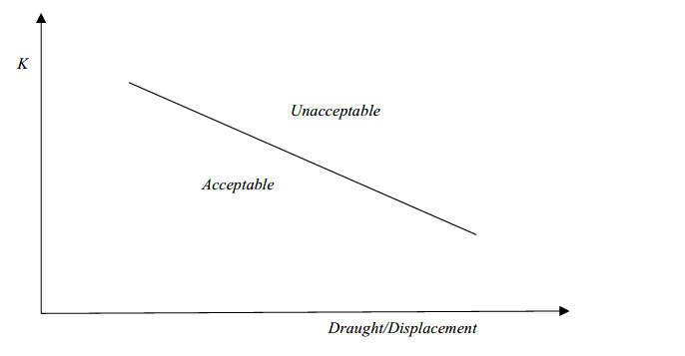
15.1 Notes on use of the curve
If, for any loading condition within the stated operational trim and draught range, the vertical centre of gravity (corrected for free surface effects) falls below the limiting curve compliance with the stability criteria contained in the Code is met.

16 BEAUFORT SCALE OF WIND SPEEDS AND CORRESPONDING PRESSURES

Beaufort Number | General Description | Limits of Speed in knots | Pressure kg/m²
0 | Calm | Below 1 | 0 to 0.02
1 | Light air | 1 to 3 | 0.02 to 0.2
2 | Light breeze | 4 to 6 | 0.3 to 0.6
3 | Gentle breeze | 7 to 10 | 0.8 to 1.7
4 | Moderate breeze | 11 to 16 | 2.0 to 4.2
5 | Fresh breeze | 17 to 21 | 4.8 to 7.3
6 | Strong breeze | 22 to 27 | 8 to 12
7 | Near gale | 28 to 33 | 13 to 18
8 | Gale | 34 to 40 | 19 to 26
9 | Strong gale | 41 to 47 | 27 to 37
10 | Storm | 48 to 55 | 38 to 50
11 | Violent storm | 56 to 63 | 52 to 66
12 | Hurricane | 64 and over | 68 and over

17 LIGHTSHIP HISTORY
An inclining experiment was undertaken at [QQ on xx/yy/xxxx]. The resulting lightship figures are as follows:
Lightship (tonnes) | LCG (m) | VCG (m) | TCG (m)

The above lightship does not include the following items which are to be included in the loading condition as deadweight items. Should any of these items be changed during the life of the yacht, the loading conditions are to be modified to take account of the difference in weight and centres of gravity and their effect on the stability of the yacht:
Item | Weight | LCG | VCG | TCG
[Main tender]

Whenever a significant change is made to the lightship, verified either by inclining experiment, lightweight check or calculation, the results are to be indicated in the following table and endorsed by an approved surveyor.
Lightship | LCG | VCG | TCG | Date | Reason

18 INCLINING EXPERIMENT REPORT

[A copy of the agreed inclining experiment report is to be included]

APPENDIX 1 – NOTES TO CONSULTANTS

Notes for consultants on the derivation of the maximum steady heel angle to prevent downflooding in gusts

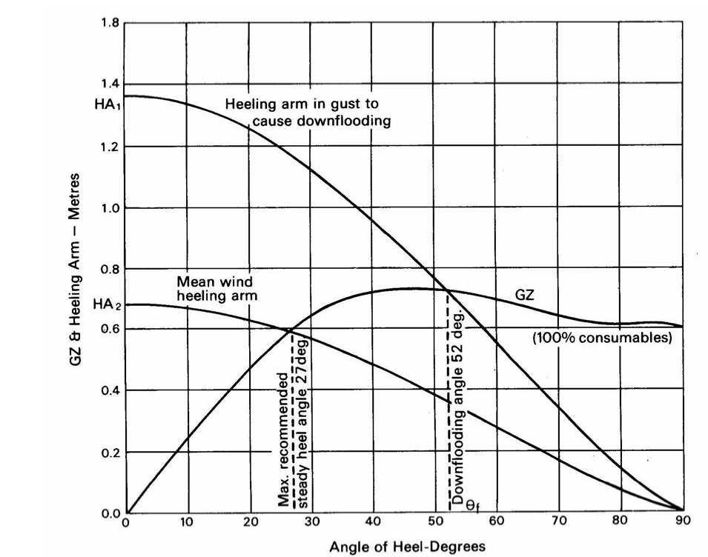

$${HA}_{1}=\frac{{GZ}_{f}}{\cos^{1.3}θ_{f}}$$

Where: HA₁ is the magnitude of the actual wind heeling lever at 0 degrees which would cause the yacht to heel to the downflooding angle $θ_{f}$, or 60 degrees, whichever is least

GZ_{f} is the lever of the yacht’s GZ curve at the downflooding able $θ_{f}$, or 60 degrees, whichever is least

HA₂ is the mean wind heeling arm at any angle $θ$ degrees
$$=0.5×{HA}_{1}×\cos^{1.3}θ$$

Notes for Consultants on the derivation of the maximum steady heel angel to prevent downflooding in squalls.

Curves of Maximum Steady Heel Angle in Squalls
The wind heeling moment is proportional to wind pressure, and the apparent wind speed squared. It is also dependent upon the area, height, shape and camber of the sails, the apparent wind direction and the prevailing gradient; however these are difficult to calculate and are not included in the consideration in the provision of Curves of Maximum Steady Heel Angle due to Squalls included in the stability information book. These curves consider only the GZ curve and the angle of downflooding, the effect of differing wind speeds being considered by proportion.

As a sailing yacht heels the wind heeling moment decreases and at any heel angle (θ) between 0 (upright) and 90 degrees it is related to the upright value by the function:

$HM={HM}_{0}\cos^{1.3}θ$ where HM₀ is the heeling moment when upright.

The heel angle of a sailing yacht corresponds to the intersection of the heeling arm (HA) with the righting arm (GZ) curve, where HA = HM/displacement.

When subjected to a gust or squall the yacht heels to a greater angle where the heeling arm curve corresponding to the gust wind speed intersects the GZ curve.

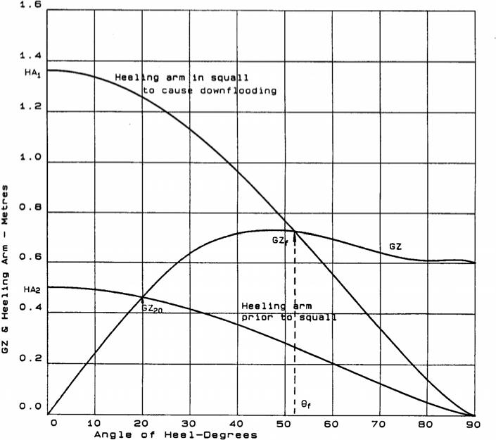
The yacht will suffer downflooding when the heeling arm curve intersects the GZ curve at the downflooding angle. This situation is illustrated in the above example diagram where the “heeling arm in squall” curve intersects the GZ curve at 52 degrees. (This “heeling arm in squall” curve can represent any wind speed).

If a scenario is assumed where sufficient sail is set to heel the yacht to the downflooding angle (60 degrees should be used if the actual downflooding angle exceeds this value) in a squall of, say 45 knots, then the wind speed can be predicted which would result in any lesser heel angle in these circumstances. The upright heeling arm in the squall (HA₁) is derived from:

$${HA}_{1}=\frac{{GZ}_{f}}{\cos^{1.3}θ_{f}}$$

If a steady heel angle prior to the squall of 20 degrees is considered, the corresponding value of the upright heeling arm HA₂ can be derived:

$${HA}_{2}=\frac{{GZ}_{20}}{\cos^{1.3}20}$$

The ratio HA₂/HA₁ corresponds to the ratio of wind pressures prior to the squall and in the squall thus for a squall speed (V₁) of say 45 knots resulting in downflooding, the wind speed prior to the squall (V₂) which would result in a heel angle of 20 degrees would be:

$$V_{2}=V_{1}$$

$$V_{2}=V_{1}{\left(\frac{{HA}_{2}}{{HA}_{1}}\right)}^{0.5}$$

In this example, which is illustrated in the diagram,
θ_{f} = 52 degrees
GZ_{f} = 0.725 metres
HA₁ = 1.362 metres
GZ₂₀ = 0.464 metres
HA₂ = 0.503 metres

Hence V2 = 27.4 knots

Thus, when sailing with an apparent wind speed of 27.4 knots at a mean heel angle of 20 degrees, an increase in the apparent wind speed of 45 knots from the same apparent wind angle would result in downflooding if steps could not be taken to reduce the heeling moment.

These values correspond to a point on the 45 knot squall curve in Figure 2, which was derived from a series of such calculations using different steady heel angles. Similarly, the curves for other squall speeds are derived using different values for V₁.

These calculations should be performed for both loading conditions and the results corresponding to the worst case (i.e. the lowest maximum steady heel angles) presented in the Stability Information Booklet.

REVISION HISTORY

Section | Description of Revision
All | First Issue

