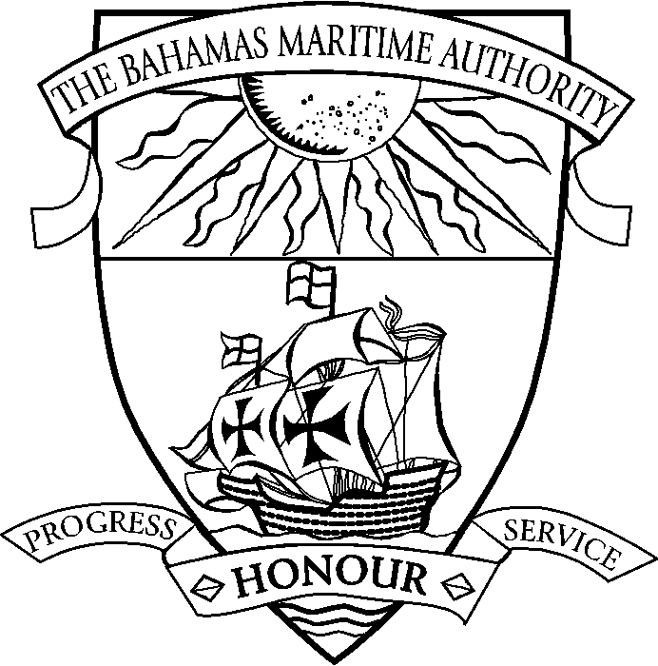 | THE COMMONWEALTH OF THE BAHAMAS  Application for a PERMIT TO OPERATE a HIGH SPEED CRAFT (HSC)

Name of Craft
Official No.
IMO No.
Manufacturer Model & Hull No.
Gross Tonnage
Category of Craft
Name of Operator
Base Port
Intended Areas or Routes of
Operation

Intended period of Operation
Maximum Distance from Place
of Refuge
Maximum Number of
Passengers Permitted

Craft Operational Limits
Significant Wave Height (Metres) | Maximum Speed (Knots)

Required Manning Scale:
Complement | Number | Number | Number

Passengers
Master-Class 1
Chief Mate-Class[ ]
Second Mate-Class[ ]*
Chief Engineer-Class1
[ ] Engineer-Class[ ]
[ ] Engineer-Class[ ]
Rating (AB/GP)-Category 1**
Cabin Crew
TOTAL
* The Chief Mate is to be certified in compliance with STCW to serve as Chief Mate on the craft taking into consideration any limitation imposed with regards to the Craft size and trading limits.

** Time served on other fast crafts to count as qualifying time for Category One Seamen after undergoing type training to an approved standard.

Any additional information that is relevant to the assessment of this application:

Applicant Name:………………………….…………… Position:…………………….……………………….

Signature:………………………………………….…… Date:……..………………………………………..

Guidance Notes
- A new permit must be applied for if the Craft is to operate on any routes other than those specified in the Permit to Operate, or if there are any changes of conditions as specified in the Permit to Operate.
- A copy of the HSC and ISM SMC is to be submitted with this application.
- Operators are to provide written confirmation that the local port/harbour authorities have been consulted and have agreed to the craft’s operation.
- No deviation from the specified route(s) shall occur unless an emergency calls for it and The Bahamas Maritime Authority and the relevant port administration(s) are formally advised.
- In addition to the survey requirements of the HSC Code, the craft is to be presented for an inspection by a Bahamian approved Nautical Inspector prior to commencement of the first commercial voyage and thereafter on an annual basis.
- All qualifications of the crew shall be in compliance with the STCW convention. All officers are to be in possession of national and Bahamian licence.
- At least one member of the cabin crew, other than the operating crew, shall be in possession of a First Aid Certificate issued in accordance with STCW Regulation VI/4.
- One Officer, but not the Master, shall be the holder of a GMDSS General Operator Certificate (GOC). In the event of a distress or urgency incident, the person designated by the Master to solely perform radio communications duties must be the holder of a GMDSS GOC.

