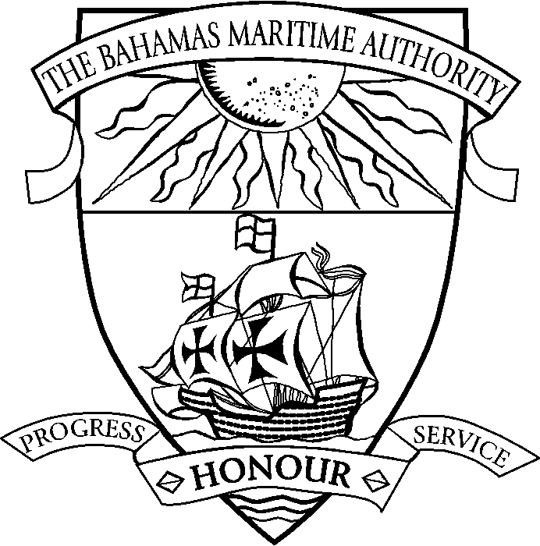 | THE COMMONWEALTH OF THE BAHAMAS  Declaration of Ownership
Official Number | IMO Number |  | Name of Ship |  |  | Port of Registry
Propulsion and Engine Details  Propulsion:  Type of Engines:  Total Power: |  |  |  | Vessel Dimensions  Length: metres  Breadth: metres  Depth: metres

Particulars of Tonnage

GROSS TONNAGE: tons NET TONNAGE: tons
I, the undersigned …………………………………………………………………………….of (a) ………………………………………………….
in the country of ………………………………………………………………….being (b) ………………………………………………………….
of (c) ………………………………………………………………………………………………………………………………………..declare as follows:
The said company was incorporated by virtue of (d) …………………………………………………………………………………………………………..
………………………………………………………………………………………………………………………………………………………….
on the …… day of ………………………………and is subject to the laws of (e) .....................................................................................................
The said company has its Registered Office/principal place of business at …………………………………………………………………………………….
where all the important business of the Company is, in fact, controlled and managed at meetings of Directors or Managers of the company.
The above described ship was built at ………………………………………………………….in the year ………………………..
The general description of the ship is correct. The said company is entitled to be registered as owner of …………………….shares in the said ship. And I make this solemn Declaration conscientiously believing the same to be true.
In witness whereof we have affixed our common seal this ……….. day of ….......................................................
Seal |  | Individual/Corporation |  |  | Attestation
 |  | name of individual/corporation  per……………………………………………..  signature as Individual/Director/Secretary/Officer  Attorney-in-fact (h)  and…………………………………………….  signature as Individual/Director/Secretary/Officer  Attorney-in-fact (h)  in the presence of the witness whose attestation is given opposite |  |  | I, (f)………………………………………………………......  of (g) …………………………………………………….......  hereby testify that in my presence  (i) this Declaration of Ownership was signed by  ................................................................................................  as Individual/Director/Secretary/Officer/  Attorney-in-fact (h)  and .........................................................................................  as Individual/Director/Secretary/Officer/  Attorney-in-fact (h)  and .........................................................................................  (ii) the corporate seal (h)/personal seal (h) of ........................  the transferee was affixed this ........... day of .........................  Signature of witness / seal .....................................................
- insert full address (b) insert the office of the person making the declaration (c) insert full name of the body corporate
(d) insert such of the descriptions as are applicable:- “an Act or Ordinance of the Legislature of ……... (cite the year in which the Act was passed, its chapter and title)” or “The Companies Act (Chapter 184)”. If incorporated prior to the Act, the Act mentioned in the certificate of incorporation should be stated.) (e) insert The Bahamas (or as the case may be). In the case of a Company incorporated by virtue of the Companies Act, insert also “and its registered office is at ………………………..”.
(f) insert name of witness. The witness to the execution of the document must be a disinterested party, independent of the body corporate or individual executing it e.g. Notary Public, Consular Officer, Magistrate, Justice of Peace. A director, officer or employee of an owner which is a body corporate should not be an attesting witness.
(g) address of witness (h) delete as applicable.

