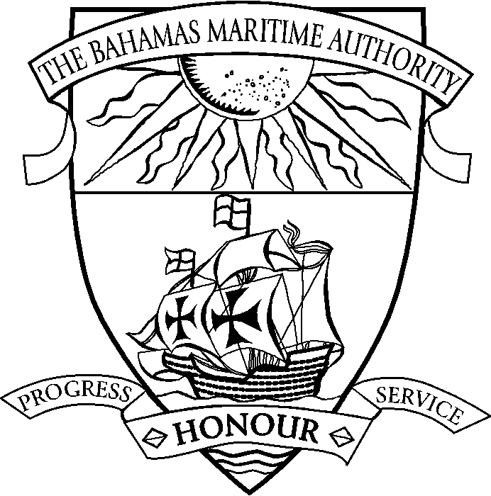 |  | THE COMMONWEALTH OF THE BAHAMAS  Appointment of Authorised Officer
Vessel Name: Official Number: IMO Number:
To the Registrar of Bahamian Ships Port of Nassau
(London, Nassau, New York, Hong Kong, Piraeus or Tokyo office)

(a) ..................................................................... having its principal place of business at .....................................................................

hereby authorises (b) ...............................................................................................................................................................................
of .............................................................................................................................................................................................................
to make and sign all Declarations of Ownership or otherwise for and on behalf of the said Company as required under the provisions of the Merchant Shipping Act, 1976.

In witness whereof we have affixed our common seal this ................................ day of .........................................................................

Seal | ………………………………………………………………….................  per .......................................................................................................  and ......................................................................................................  in the presence of the witness whose attestation is given below* |  | .(insert name of individual/corporation)  (insert signature of Individual/Director/  Officer/Secretary/Attorney-in-fact)  (insert signature of Individual/Director/  Officer/Secretary/Attorney-in-fact)
I, (c) …………………………………………………….. of (d) ………………………………….……………………......................

……………………………………………… hereby testify that in my presence

(i) this Appointment of Authorised Officer was signed by (e) ……………………………………………………………...................

as Individual/Director/Officer/Secretary/Attorney-in-Fact(f) and (e)……………………………………………………….................

as Individual/Director/Officer/Secretary/Attorney-in-fact(f) and .........................................................................................................

(ii) the seal of the corporation/individual was affixed this …………..day of ……………………………….……………..................

Signature of witness / seal .................................................................

(a) insert name of corporation/individual, (b) insert name of individual to be appointed authorised officer
(c) insert name of witness, (d) insert address of witness, (e) insert name of official, (f) delete as applicable.
*The witness to the execution of the document must be a disinterested party, independent of the body corporate or individual executing it e.g. Notary Public, Consular Officer, Magistrate, Justice of Peace. A director officer or employee of an owner which is a body corporate should not be an attesting witness.

